**Team Name:** Coding Nerds

**Languages Used:** Python, Java

Problem 1:

Output 1:

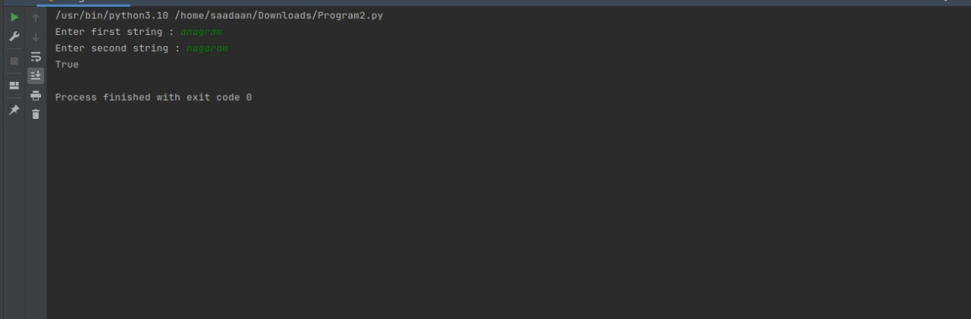

Output 2:

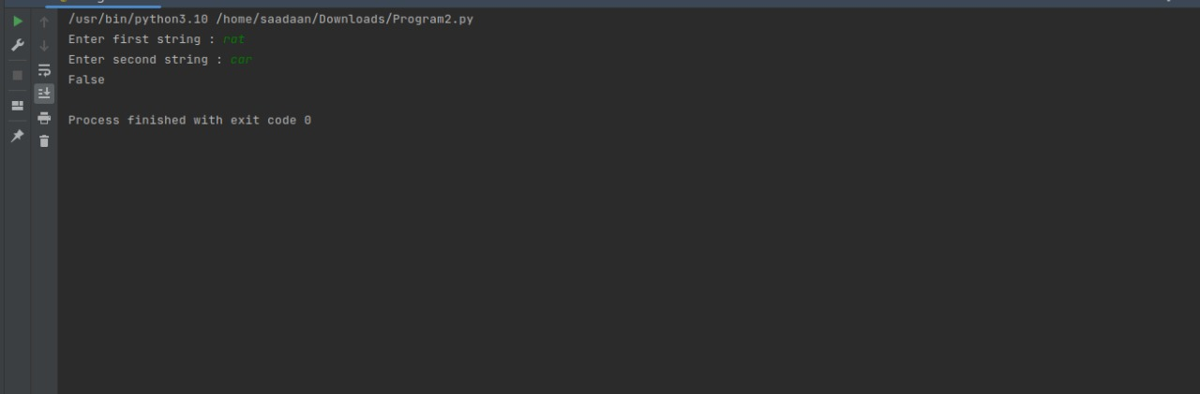

**Program:2**

Output

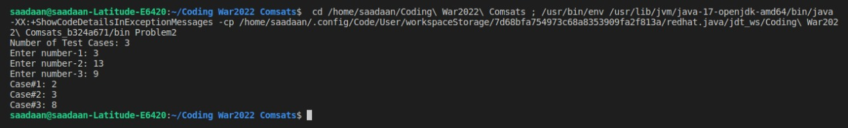

Problem 3:

Output:

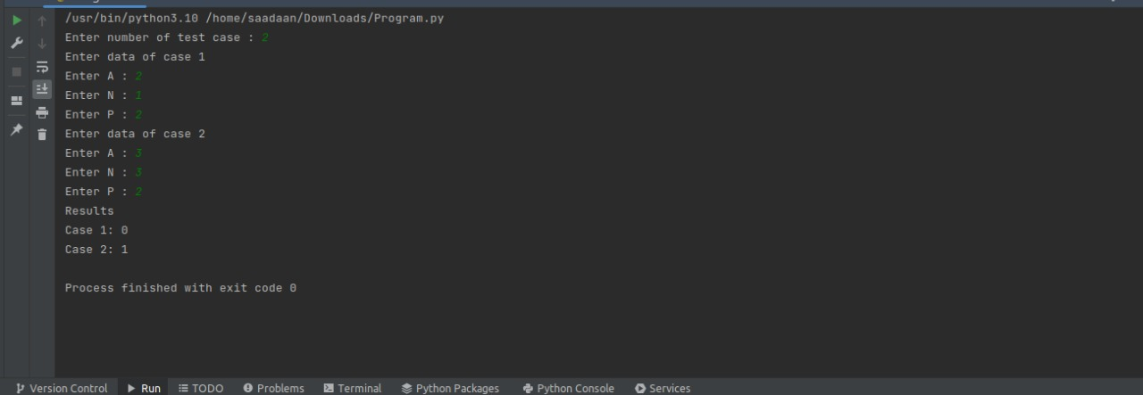

**Problem 4:**

**Output:**

